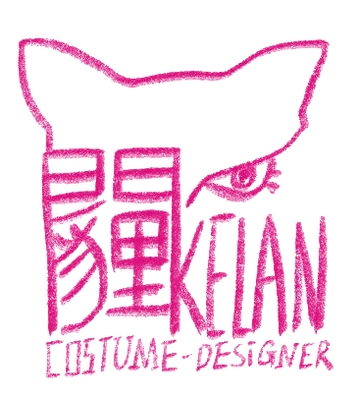
KELAN YANG COSTUME DESIGNER
San Diego, CA | Chengdu, China
kelanyangdesign@gmail.com | kyang5746@sdsu.edu | www.kelan-yang.com
Selected Costume Design
Production | Company | Directed by | Year
Six Characters in Search of an Author | SDSU TTF Prebys | Dr. Katie Turner | 2025
Waiting for Godot | SDSU TTF Main Stage | Peter James Cirino | 2024
Children of Eden, in Concert | SDSU TTF Main Stage | Stephen Brotebeck | 2023
Perpetual (E)MOTION | Malashock Dance Company | John Malashock | 2023
Costume Design Assistant
Production | Company | Directed by | Designed by | Year
Oklahoma! | Cygnet Theatre | Sean Murray | Zoë Trautmann | 2025
In a Sunshine State | SDSU TTF Main Stage | Stephen Brotebeck | Katherine Paulsen | 2024
Mr. Burns, a Post-Electric Play | SDSU TTF Main Stage | Jesca Prudencio | Mayté Martínez | 2023
Cabaret | SDSU TTF Main Stage | Stephen Brotebeck | Claire Peterson | 2023
Weight of Dreams | SDSU TTF Main Stage | Peter James Cirino | Mayté Martínez | 2023

Costume Crafts & Special Projects
Production | Project | Produced by | Directed by | Year
Hamlet | Masks/Crowns Making | SDSU TTF Prebys | Dani Bedau | 2025
A New Brain | Hand Puppet Making | SDSU TTF Prebys | Josh Walden | 2024
The House of Bernarda Alba | Embroidery Work | SDSU TTF Prebys | Peter James Cirino | 2024
Mr. Burns, a Post-Electric Play | Masks Making | SDSU TTF Main Stage | Jesca Prudencio | 2023
ZIGGY, STARDUST & ME | Embroidery Work | SDSU TTF Prebys | Dani Bedau | 2023
Weight of Dreams | Fabric Modification | SDSU TTF Main Stage | Peter James Cirino | 2023

Skills/Languages

Professional Skills:
Stitching, Illustration, Sculpting, Puppet making, Sourcing, Craft, Adobe Photoshop, Procreate, Adobe Premiere Pro, CLO3D

Languages:
Chinese (Native), English (Fluent), Japanese (Basic)

Education

MFA in Costume Design, San Diego State University, Expected graduation 2026

BA in General Theatre, San Diego State University, Graduated by 2023
References

Denitsa Bliznakova, San Diego State University, Head of Design and Technology, dbliznak@sdsu.edu
Teri Tavares, San Diego State University, Costume Shop Manager, tavares@sdsu.edu
Dr. Katie Turner, San Diego State University, Lecturer, Assistant School Director Theatre, laura.turner@sdsu.edu

